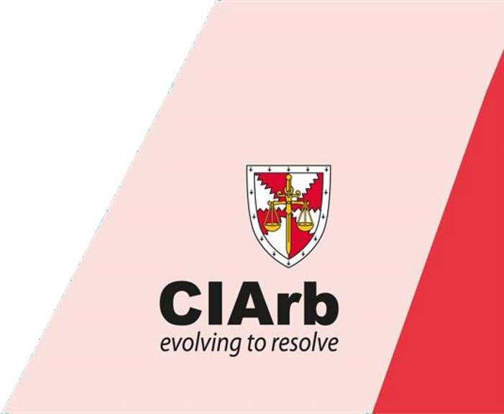
What is the aim of the programme?

Course Information

3rd – 5th March 2021 Accelerated Route to Fellowship –
Internationanal

–

International Arbitration

To provide a fast-track route to Fellowship through the International (i.e. non-domestic) Arbitration Pathway. The Accelerated Route to Fellowship has been designed for busy professionals who have substantial unassessed knowledge and experience of International Arbitration. The aim of the programme is to assess whether the candidate has the knowledge required to apply the principles and procedure of International Arbitration using arbitration legislation based on the UNCITRAL Model Law and Arbitration Rules and is capable of writing an reasoned and enforceable International Arbitration Award.
Candidates must evaluate their personal suitability to undertake the programme, appreciating that the assessments are intensive and that they will be assessed against standard benchmarks.
This programme focuses on the process, practice and procedures in International Arbitration which is an essential requirement for qualification as a Fellow and for those who aim to practice as an International Arbitrator.

What are the learning outcomes?
On successful completion of this course candidates will be able to:
- Identify and explain in depth all the key elements of the International Arbitration process;
- Evaluate issues and apply the principles of the UNCITRAL Model Law appropriately;
- Demonstrate practical skill in carrying out the tasks required in preparing for and progressing an International Arbitration;
- Demonstrate skill in controlling an International Arbitration, communicating effectively with the parties, applying the UNCITRAL Arbitration Rules and adopting appropriate procedures.

What is covered within the syllabus?
- Arbitration agreements;
- The legal framework: the importance of the seat, the New York Convention, procedural laws, and procedural rules; conflict of laws, the Rome Convention;
- The use and adoption by State entities of the UNCITRAL Model Law;
- The UNIDROIT Principles of International Commercial Contracts;
- Types of Arbitration: ad-hoc, institutional, documents only, time limited;
- Commencement of the Arbitration, terms of reference;
- Obligations of the Tribunal, responsibilities and obligations of the parties;
- The Arbitrator’s terms and conditions of appointment;
- An Arbitrator’s jurisdiction and powers;
- Challenges to jurisdiction, conflicts of interest;
- Managing the Arbitration process: communications, preliminary meeting, interlocutory matters, dealing with factual and opinion evidence and disclosure of documents;
- Security for costs;
- Presenting the claim and the defence: alternative methods;
- Preparation for and procedure at a typical hearing, contrasting common law and civil law jurisdictions; • Essentials of an enforceable Award;
- Costs, offers and interest; alternative approaches in different jurisdictions.

How is the programme delivered?
This is an assessment programme as opposed to a teaching module. Learning will be based on private study prior to the oral assessment workshop, reinforced by tutor input and peer discussion during the workshop.
The programme is delivered over a period of three days, with assessment workshops on days one and two. On day three candidates sit a four hour examination. The programme dates advertised are the dates when candidates will be required to attend the assessment workshops.

How will I be assessed?
Assessment of this programme is split into three parts, all of which must be passed:
- Assessment 1 - An interactive 2 day assessment in a series of workshops, where situations will be presented to candidates in groups for their consideration. Candidate’s knowledge, judgment and interactive/self-presentation skills are assessed by oral exercises.
- Assessment 2 - Written exercises before and during the 2-day workshops: o one written exercise on arbitration law to be submitted before the assessment workshops (10%); o one written exercise on arbitration law to be submitted during the workshops (20%); o two written exercises to be submitted during the workshops (10% each); o one written exercise to be completed overnight (30%); and o a final written exercise (20%).
Assessment 3 - Final examination for this course is a 4 hour open book examination. (70%)

Details of the assessment are as follows:
- Assessment 1 (Oral Exercises). This assessment is on a pass or fail basis. Candidates must pass all the workshop sessions. Candidates who fail the workshop will be required to re-sit this assessment.
- Assessment 2 (Written Exercises). Candidates must achieve a minimum overall mark of 55% to pass this assessment.
- Assessment 3. Final examination for this course is a 4 hour open book examination. Additional information is provided on the day of the assessment in form of the Arbitrator’s notebook. Candidates must achieve a minimum overall mark of 70% to pass the course.

Candidates are permitted to use any materials they wish throughout the workshops.

Results are dispatched to candidates normally eight to twelve weeks from the date of the submission of the examination.

What are the entry requirements?
In order to register for the Accelerated Route to Fellowship, candidates must submit evidence to show:
- They have a minimum of 5 years of practical experience of international arbitration either as a representative or an international arbitrator;
- They have substantial knowledge of the framework of international arbitration;
- They can recognise and evaluate evidence;
- They can significantly evaluate and apply the principles and requirements of an international arbitration;
- They can noticeably demonstrate practical skill in the carrying out of tasks required in preparing for and progressing an international arbitration.

English Language Competence - CIArb training and assessment is carried out in English it is therefore essential that candidates are proficient in both written and spoken English. Where English is not a candidate’s first language it is recommended that they have achieved a standard that is, as a minimum, equivalent to the International English Language Testing System (IELTS) level 7 or a score of 94-101 in the Test of English as a Foreign Language (TOEFL) system. CIArb issues this advice as a guideline and, while it will not require any evidence of this standard prior to enrolment on a course, candidates who do not have this standard of English may be disadvantaged.

What is the programme fee and what does it include?
The programme fees are N400,000.00 and £408. The fees include registration on the programme, the first attempt at the assessments, study materials, lunch and refreshments throughout the day. Please note that the fees are subject to change.

What happens when I register for the programme?
Upon successful registration on the programme, candidates will receive confirmation they are booked on the programme. Joining instructions and course materials will be sent to candidates approximately 2 weeks before the course start date by email.

Candidates will be provided with an electronic copy of a Workbook to assist them with their studies together with a suggested reading list. It is recommended that candidates are familiar with the UNCITRAL Model Law and Arbitration Rules and the substantive law in their respective jurisdiction together with the relevant Act(s) and Scheme(s) and important case decisions (where applicable). Candidates should also refer to the recognised standard text books to supplement their study in their respective jurisdiction where these are available.

What is CIArb’s policy on cancellation of courses?
CIArb reserves the right to cancel or change the date, venue or content of programmes and the names of speakers, lecturers and tutors. Candidates will be provided with adequate notice of any change. If CIArb has to cancel a course, candidates will be provided with a full refund or the opportunity to transfer their registration to the next course. Should a candidate wish to cancel their registration of a course, notification must be received in writing to ciarbnigeria@gmail.com. The following cancellation charges apply:
Notice Period Cancellation Deferment/Rescheduling
Less than 1 month Full fee N40, 000
1-2 months N50, 000 N30, 000
2 months N20, 000 N20, 000

What is my next step when I complete the programme?
On successful completion of this programme, candidates:
- Will be eligible to apply for Member grade of CIArb, and take advantage of a range of educational and professional benefits.
- Be eligible for a Peer Interview for Fellowship.

CHECK SHEET FOR THE ACCELERATED ROUTE COURSES

Please tick the appropriate box
Yes No

- Have you read the course information sheet?

- Do you meet the entry criteria for the course?

- Is the reading list and syllabus part of the documents you received upon
registration for the course?

- Do you appreciate that that the Accelerated Route Courses are non-teaching
courses ?

- Are you aware that there is a pre-course assignment to be submitted before the
Course? (Please note that this forms part of the final assessment)

Name: ………………………………………………………… Signature & Date: ………………………………………………………

2021 Registration Form
The Chartered Institute of Arbitrators, Nigeria Branch, 5B, Kunle Ogunba Street, Off Jeremiah Ugwu, Off Babatunde Anjous, Off Admiralty Way, Phase One, Lekki, Lagos, Nigeria.

Please register me for the Accelerated Fellowship Program on:

March 3 – 5, 2021

Completed application form should be returned to the above address on or before 19th February, 2021.

N.B. Applications cannot be processed unless accompanied by the appropriate fee.
Payments should be made in favour of the Chartered Institute of Arbitrators
by bank deposits or transfer to UBA Bank Account No. 1007123970 and UBA Domiciliary Account No.: 3002894213.

Any cost arising out of unpaid or uncleared cheque will be met by the Applicant.

Surname ______________________ First Name _____________________________________________

Suffix (e.g. SAN) _______________ Title (Mr., Mrs., Other) ________________________________________

Firm/Company/Institution ____________________________________________________________________

Address _____________________________________________________________________________________

____________________________________ City _____________________________________________

Postcode _____________________ Country ______________________________________________________

Tel. _______________________ E-mail ____________________________________________________________

Date of Birth ________________ Name on Badge (if different from above _________________________

Special Dietary Requirements _________________________________________________________________

Primary Profession _________________________ Date qualified as Lawyer __________________________

Method of Payment
Payment in bank draft or cheque will be accepted.
- I enclose a cheque or bank draft made payable to The Chartered Institute of Arbitrators, Nigeria Branch
Number _______________________________________________

Signature ______________________________________________

Where did you hear about this course?
Website Mailing Recommendation by previous course attendee

Ot Other method, please specify ____________________________________________________

Data Protection

I a I agree to my name, address and email address appearing in the List of Participants.

ACCELERATED ROUTE TO FELLOWSHIP – INTERNATIONAL ARBITRATIONAL
READING LIST

*Workbook:
Modules 1 and 3

*1958 New York Convention
*IBA Guidelines on Conflict of November 2014 Full
*IBA Rules on Taking of Evidence in International Arbitration 2010
*Module 1 International Arbitration
*Module 3 Arbitration
*UNCITRAL Arbitration- Rules -Revised -2010 –e
*UNCITRAL Model Law 2006 Amended
*UNDROIT Principles 2016-e

*Arbitration Interactive
Klaus Peter Berger
Published by Qadis Publishing
Email: publishing@quadis.com

*Law & Practice of International Commercial Arbitration
By Redfern & Hunter (3rd Edition).

*International Commercial Arbitration in UNCITRAL Model Law Jurisdictions
Peter Binder
Sweet & Maxwell 2000 ISBN 0421 73940 1

*Arbitration Awards (A Practical Approach)
By Ray Turner
Blackwell Publishing

*International Arbitration: Law and Practice
Second Edition
Gary B. Born
Published by Wolters Kluwer

Other Books Available About Arbitration

Introduction to Arbitration: (Harold Crowter)
Arbitration Practice and Procedure – Interlocutory and Hearing Problems (D Mark Cato)
Construction Arbitrations (Powell-Smith, Sims and Dancaster)
Costs in Arbitration Procedures (Michael O’Reilly)

