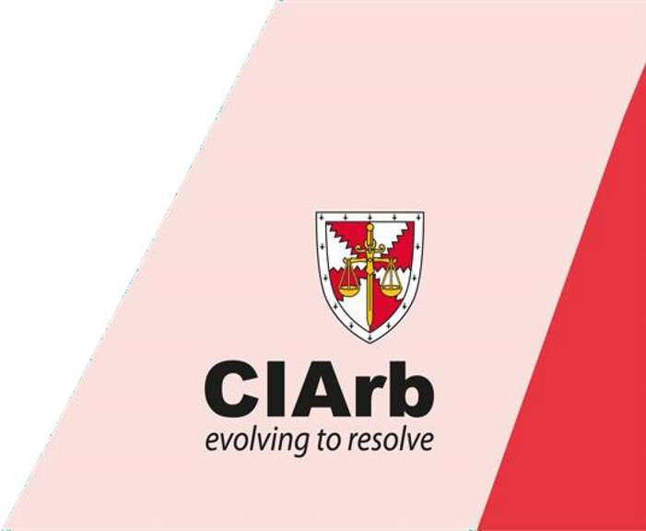
To provide a fast-track route to Membership through the International (i.e. non-domestic) Arbitration Pathway. The Accelerated Route to Membership has been designed for busy professionals who have some unassessed knowledge of International Arbitration. The aim of the programme is to assess whether the candidate has the knowledge required to understand the process of International Arbitration.

What is the aim of the programme?

Course Information

14th & 15th July 2021 Accelerated Route to Membership -

–

International Arbitration Jos

Candidates must evaluate their personal suitability to undertake the programme, appreciating that the assessments are intensive and that they will be assessed against standard benchmarks.
The programme covers the law underpinning the process and procedure of International Arbitration. It is therefore valuable for anyone who is conversant with the law and practice of International Arbitration generally, whether as a party or party representative. It is also an essential step for anyone aiming for Fellowship and for those who aim to practice as an Arbitrator.

What are the learning outcomes?
On successful completion of this programme candidates will be able to:
- Explain the principles and specific legal requirements in an International Arbitration: o The legal framework including limitations of matters that may legally be arbitrated; o The contractual nature of the appointment of an Arbitrator; o The rights, duties and responsibilities of a party to an Arbitration; o The range and limitations of an Arbitrator’s powers and jurisdiction; o The methods of initiating and processing an Arbitration; o The relevance of the court regarding all stages in an Arbitration; o The requirements of an enforceable Award;
- Evaluate and apply the principles and legal requirements of an International Arbitration;
- Identify, explain and apply the legal procedural principles, rules and arguments relevant to the conduct of an International
Arbitration

What is covered within the syllabus?
- Fundamental principles of the Arbitration process; • The UNCITRAL Model Law and Arbitration Rules;
- The Arbitration agreement:
- Commencement of an Arbitration and appointment of an Arbitrator;
- Obligations of the Tribunal, responsibilities and obligations of the parties;
- An Arbitrator’s jurisdiction and powers;
- The Arbitration process: meetings, timetable, submissions, experts, disclosure, hearings;
- The powers of the Court;
- Interest and Costs;
- Essentials of an enforceable Award; • Challenges, appeals and enforcement.

How is the programme delivered?
This is an assessment programme as opposed to a teaching module. Learning will be based on private study prior to the oral assessment workshop, reinforced by tutor input and peer discussion during the workshop.
The programme is delivered over a period of two days, with assessment workshops on day one and an examination on day two. The programme dates advertised are the dates when candidates will be required to attend the assessment workshops and examination.

How will I be assessed?
Assessment of this programme is split into three parts:
- Assessment 1 - An interactive 1 day assessment in a series of workshops, where situations will be presented to candidates in groups for their consideration. Candidate’s knowledge, judgment and interactive/self-presentation skills are assessed by oral exercises.
- Assessment 2 - A written assignment to be submitted before the programme (20%).
- Assessment 3 - A 3-hour closed book examination, split into two parts.
(Part One) Is a case study exercise with a number of questions that candidates will be required to answer. Available marks 40%.
(Part Two) Will consist of five questions, candidates are required to select and answer three. Available marks 60% (20% per question).

Details of the assessments are as follows:
- Assessment 1 (Workshop). This assessment is on a pass or fail basis. Candidates must pass all the workshop sessions. Candidates who fail the workshop will be required to re-sit this assessment.
- Assessment 2 (Assignment). This assessment is not on a pass or fail basis. The mark achieved will contribute up to 20% of the final mark.
- Assessment 3 (Examination). This assessment is on a pass or fail basis. Candidates must achieve a minimum of 55%. Candidates who fail the examination will be required to re-sit the examination.
- The overall assessment is based upon the combined marks of Assessment 2 and Assessment 3. Candidates must achieve a minimum overall mark of 55% to pass the programme.

The examination is closed book; no materials are permitted in the examination room except for an unmarked copy of the UNCITRAL Model Law (incorporating the 2006 amendments) and Arbitration Rules (2010 revision). Highlighting and underlining is permitted. Candidates are permitted to use any materials they wish throughout the workshops.

Results are dispatched to candidates normally eight to twelve weeks from the date of the submission of the examination.

What are the entry requirements?
In order to register onto the Accelerated Route to Membership, candidates must submit evidence to show:
- They have knowledge of the framework of international arbitration;
- They can evaluate and apply the principles and requirements of an international arbitration;
- They can demonstrate awareness of the practical tasks required in preparing for and progressing an international arbitration.

English Language Competence - CIArb training and assessment is carried out in English it is therefore essential that candidates are proficient in both written and spoken English. Where English is not a candidate’s first language it is recommended that they have achieved a standard that is, as a minimum, equivalent to the International English Language Testing System (IELTS) level 7 or a score of 94-101 in the Test of English as a Foreign Language (TOEFL) system. CIArb issues this advice as a guideline and, while it will not require any evidence of this standard prior to enrolment on a course, candidates who do not have this standard of English may be disadvantaged.

What is the programme fee and what does it include?
The programme fees are N175,000.00 and is £174. The fee includes registration on the programme, the first attempt at the assessments, study materials, lunch and refreshments throughout the day. Please note that the fees are subject to change. Payment can be done by bank deposits or transfer to the Institute UBA Account No. 1007123970 and UBA Domiciliary Account No. 3002894213. The account name is Chartered Institute of Arbitrators.

What happens when I register for the programme?
Upon successful registration on the programme, candidates will receive confirmation they are booked on the programme. Joining instructions and course materials will be sent to candidates approximately 2 weeks before the course start date by email.

Candidates will be provided with an electronic copy of a Workbook to assist them with their studies together with a suggested reading list. It is recommended that candidates are familiar with the UNCITRAL Model Law and Arbitration Rules and the substantive law in their respective jurisdiction together with the relevant Act(s) and Scheme(s) and important case decisions (where applicable). Candidates should also refer to the recognised standard text books to supplement their study in their respective jurisdiction where these are available.

What is CIArb’s policy on cancellation of courses?
CIArb reserves the right to cancel or change the date, venue or content of programmes and the names of speakers, lecturers and tutors. Candidates will be provided with adequate notice of any change. If CIArb has to cancel a course, candidates will be provided with a full refund or the opportunity to transfer their registration to the next course. Should a candidate wish to cancel their registration of a course, notification must be sent in writing to ciarbnigeria@gmail.com. The following cancellation charges apply:
Notice prior to commencement of event Cancellation Charge
Over two weeks Full refund
One to two weeks 50% refund
Less than one week No refund
A delegate may also defer to the next available date. Deferment of two weeks or less to the course will attract a 50% penalty.

What is my next step when I complete the programme?
On successful completion of this programme, candidates:
- may progress onto Module 3 of the International Arbitration Pathway;
- will be eligible to apply for Member grade of CIArb, and take advantage of a range of educational and professional benefits.

CHECK SHEET FOR THE ACCELERATED ROUTE COURSES

Please tick the appropriate box
Yes No

- Have you read the course information sheet?

- Do you meet the entry criteria for the course?

- Is the reading list and syllabus part of the documents you received upon
registration for the course?

- Do you appreciate that that the Accelerated Route Courses are non-teaching
courses ?

- Are you aware that there is a pre-course assignment to be submitted before the
Course? (Please note that this forms part of the final assessment)

Name: ………………………………………………………… Signature & Date: ………………………………………………………

14th & 15th July 2021 Accelerated Route to Membership – International Arbitration Jos
APPLICATION FORM

Title: Mr., Mrs., Miss, Dr., Prof., Chief,

First Name (Block Capitals) …………………………………………………………………………….

Middle Name (Block Capitals) ……………………………………………………….…………………

Surname (Blocks Capitals) ……………………………………………………….…………………….

Date of Birth ……………………………………………………………….………………………….

Physical Address ………………………………………………………….…………………………….

Tel. No: ………………………….. …………….. E.-mail…………..………………………………

Primary Profession /Trade ………………………………………………………………………………

Qualifications ……………………………………………………………………………………………

Firm/Organisation ……………………………………………………………………………………….

Previous arbitration courses attended with dates ………………………………………………………..

Previous arbitration exams passed with dates …………………………………………………………..

Statement of Dispute Resolution experience (attach a separate sheet)

I am a member/ non member of the Institute (delete which is inapplicable)

I wish to attend the Accelerated Membership Programme and enclose herewith is the evidence of payment (include details)

Notes: i) Please complete a separate form in respect of each applicant
- Payments should be made in favour of the Chartered Institute of Arbitrators
by bank deposits or transfer to UBA Bank Account No. 1007123970 and First Bank
Domicilary Account No. 2004654759.
- Any cost arising out of unpaid or uncleared cheque will be met by the
Applicant.

In the event of a cancellation, which must be done in writing, the following will
apply:-
Notice prior to commencement of event Cancellation Charge
Over two weeks Full refund
One to two weeks 50% refund
Less than one week No refund
A delegate may also defer to the next available date. Deferment of two weeks or less to the course will attracts a 50% penalty.

The completed form and evidence of payment must be submitted on or before June 4, 2021
Note: Registration is subject to space availability

Signature:………………….................. Date: ….........................................
For Official Use only – date of Receipt of Application
Receipt No:

ACCELERATED ROUTE TO MEMBERSHIP – INTERNATIONAL ARBITRATION
READING LIST

*Workbook

*Arbitration Interactive
Klaus Peter Berger
Published by Qadis Publishing
Email: publishing@quadis.com

*Law & Practice of International Commercial Arbitration
By Redfern & Hunter (3rd Edition).

*International Commercial Arbitration in UNCITRAL Model Law Jurisdictions
Peter Binder
Sweet & Maxwell 2000 ISBN 0421 73940 1

*Arbitration Awards (A Practical Approach)
By Ray Turner
Blackwell Publishing

*International Arbitration: Law and Practice
Second Edition
Gary B. Born
Published by Wolters Kluwer

**UNCITRAL Model Law 2006 Amendment

**UNCITRAL Arbitration Rules (as revised in 2010)

**The 1958 New York Convention

Other Books Available About Arbitration

Introduction to Arbitration: (Harold Crowter)
Arbitration Practice and Procedure – Interlocutory and Hearing Problems (D Mark Cato)
Construction Arbitrations (Powell-Smith, Sims and Dancaster)
Costs in Arbitration Procedures (Michael O’Reilly)

